Standardized format for Translation
_______________________________________________________________________________________________________________________________

Video Title Translation: NA

Video link: https://drive.google.com/file/d/1CqVOAMLSCYpj3HY04aE9d5su_qLh9zu5/view?usp=sharing

Language: Hindi

Linguist Profile Name: Ajmal

Instructions:
1. Please provide per minute of translation as per the timestamp format mentioned in the doc (hours: minutes: seconds).
2. Kindly translate word for word ensuring proper grammatically structured sentences in a high quality global standard English.
3. Translations should reflect cultural understanding and context needed to understand metaphors/slurs/slang in the Source Content. Please translate idioms, metaphors, and similes literally. If no direct translation exists in English, please provide the English equivalent or the intended meaning in brackets or parentheses; and mention in the “Notes” column that the idiom, metaphor, and simile used does not have an exact English translation.
4. Please edit, proofread, re-check the punctuation & grammatical errors.
5. Please leave a comment in the “Notes” column of the Translated Document where specific and detailed hateful and abusive language, ethnic discourse or incitement to violence is mentioned in the Source Content.
6. No omission or addition of words should be there to ensure context appropriation of the content.
7. Maintain the same style throughout the translation.
8. Label and identify the speakers as they speak.
9. Please translate video titles, write a summary of 2-3 lines about what the video is about and all other on-screen text - static or moving along with video title/disclaimer/thumbnail wherever present in the video.
10. Proper nouns like names of people, places, etc. can be elaborated in the “Notes” section the significance of the person or place of interest where applicable and useful to the reader.
Note: Please translate the description, Thumbnails as well
Please provide only manual translation, machine translation would be outrightly rejected

Additional Comments:

Video Thumbnail: NA

Video Description: NA

Video Summary: The video contains screen recording of a telegram app group chat in which the users are engaging into conversation and asking about the alleged leaked papers of NEET UG Exams 2026 that was conducted on May 3rd, 2026. Apparently, the group chat owner was selling the papers in the group chat and users were buying it and were seen thanking the group admin for sharing the leaked papers. The video also contains a Hindi movie song dubbed over the video where the singer is so consumed by devotion to his lover that they have traded worldly logic for the "madness" of love. By seating their memories close and surrendering to every whim of the heart, the lover enters a state of perpetual prostration.

Timestamp | WfW translation | OST | Notes
00.00.00- 00.01.00  Ajmal | [Music + non-lexical sound -00:00:00 - 00:00:17]  Background Male Singer voice : Started staying in prostration of my beloved so much, the world started calling me “insane, insane.” Catering to my every colorful need, sitting memories down beside me, started staying in prostration of my beloved, kept flowing… |   Telegram  Search Chats  LEAK MAFIA  PRIVATE MAFIA  19:09  Your request to join the group was ap...    Chats  Contacts  Settings  S  Profile    LEAK MAFIA  PRIVATE MAFIA  336 members, 102 online    Pinned Message #2  Check the message on top, I have added.  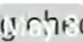  3 MAY  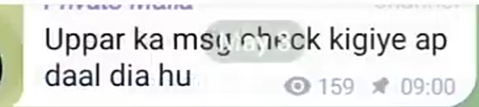  Check the message on top, I have added.  159 09.00  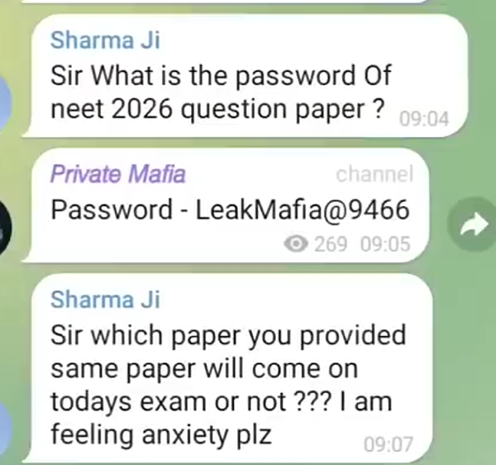  Mr Sharma  Sir What is the password Of neet 2026 question paper?  09:04  Private Mafia  channel  Password - LeakMafia@9466  269  09:05  Mr Sharma  Sir which paper you provided same paper will come on todays exam or not ??? I am feeling anxiety plz  09:07  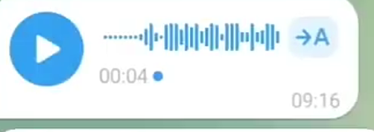  00:04.  →A  09:16  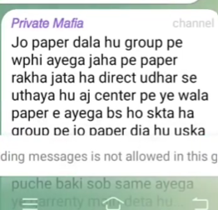  Private Mafia Channel…  The paper that’s added in the group, the same will come. I have taken it from where the paper is kept. Today this paper will come at the center but may be the paper added in the group, its    Sending messages is not allowed in this group.  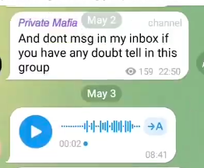  Private Mafia  May 2  channel  And dont msg in my inbox if you have any doubt tell in this group  159  22:50  May 3  00:02  08:41  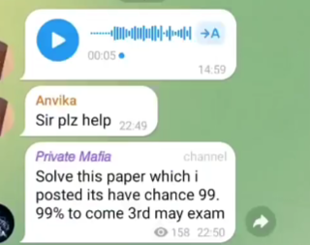  →A  00:05  14:59  Anvika  Sir plz help  22:49  Private Mafia  channel  Solve this paper which i posted its have chance 99. 99% to come 3rd may exam  158  22:50  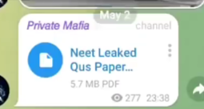  May 2  Private Mafia  channel  Neet Leaked Qus Paper...  5.7 MB PDF  277 23:38  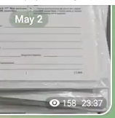  May 2  158 23:37  Channel    Soon i shall upload full paper kindly note th…  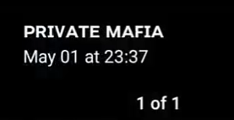  PRIVATE MAFIA May 01 at 23:37  1 of 1  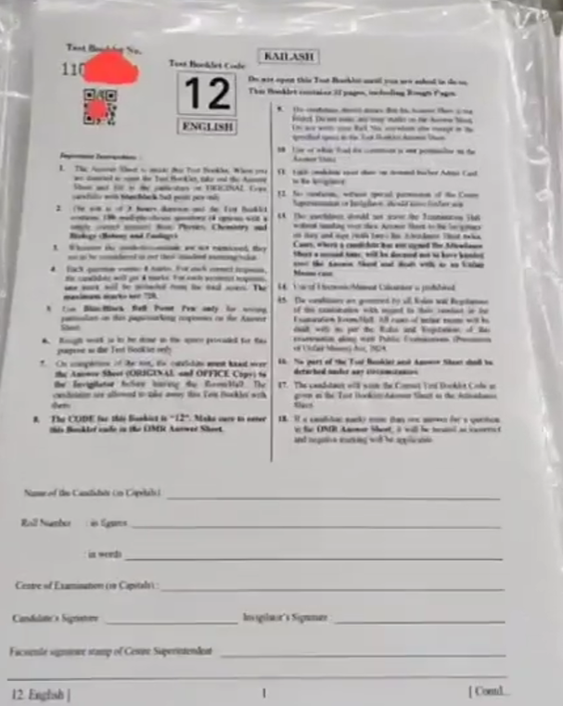  11…  KAILASH  1  2  3  4  5  6  7  8  9  10  11  12  13  14  15  16  17  18  Name of the…..  Roll Number  In….  In words  Centre of Examination (in Capitals] :  …. Sig…..  …… .. ..  12. E……  1  ……  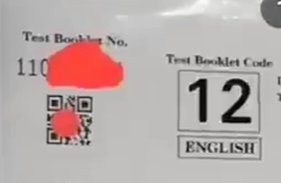  Test Booklet No.  110  Robero  Test Booklet Code  12  ENGLISH  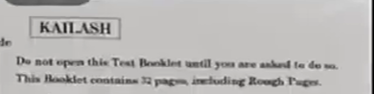  KAILASH  Do not open this Test Booklet until you are asked to do so. This Booklet contains 32 pages, including Rough Pages.  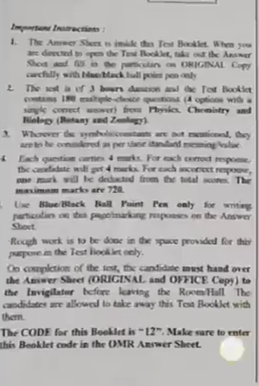  Important ……:  1. The Amway Sheet is inside this Test Booklet. When you are directed to open the test Booklet, take out the Answer Sheet and fill in the particulars on ORIGINAL Copy carefully with blueblack hall point pen only  2. The …. 3 hours duration and the Fest Booklet contains 180 multiple-choice questions (4 options with a single correct answer) from Physics, Chemistry and Biology (Botany and Zoology).  3. Wherever the symbolcants are not mentioned, they are …. be considered as per these standard meaning Valve  Each question carries 4 marks. For each correct response the candidate will get 4 marks. For each incorrect response, one mark will be deducted from the total scores. The maximum marks are 720.  Use Blue/Black Ball Paint Pen only for writing parti….. on this papermarking responses on the Answer Sheet  Rough work is to be done in the space provided for this purpose in the Test Booklet only.  On completion of the test, the candidate must hand over the Answer Sheet (ORIGINAL and OFFICE Copy) to the Invigilator before leaving the Room Hall The candidates are allowed to take away this Test Booklet with them.  The CODE for this Booklet is "12". Make sure to enter this Booklet code in the OMR Answer Sheet.  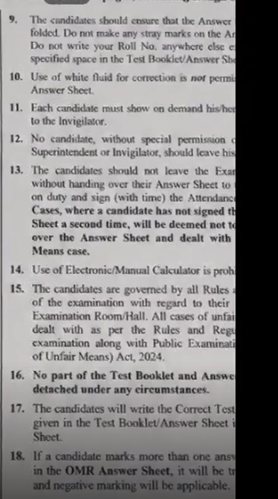  9. The candidates should ensure that the Answer …..folded. Do not make any stray marks on the An Do not write your Roll No. anywhere else e specified space in the Test Booklet/Answer Sho  10. Use of white fluid for correction is not permis…. Answer Sheet.  11. Each candidate must show on demand his/her to the Invigilator.  12. No candidate, without special permission ….Superintendent or Invigilator, should leave his…  13. The candidates should not leave the Exar without handing over their Answer Sheet to on duty and sign (with time) the Attendance Cases, where a candidate has not signed th…. Sheet a second time, will be deemed not to…. over the Answer Sheet and dealt with Means case.  14. Use of Electronic/Manual Calculator is proh….  15. The candidates are governed by all Rules of the examination with regard to their Examination Room/Hall. All cases of unfai…. dealt with as per the Rules and Regu… examination along with Public Examination of Unfair Means) Act, 2024.  16. No part of the Test Booklet and Answer detached under any circumstances.  17. The candidates will write the Correct Test given in the Test Booklet/Answer Sheet i Sheet.  18. If a candidate marks more than one answer in the OMR Answer Sheet, it will be tr and negative marking will be applicable.  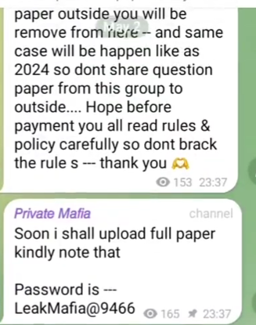  paper outside you will be remove from here -- and same case will be happen like as 2024 so dont share question paper from this group to outside.... Hope before payment you all read rules & policy carefully so dont brack the rule s --- thank you  153 23:37  Private Mafia  channel  Soon i shall upload full paper kindly note that  Password is ---LeakMafia@9466  165  23:37    Forward  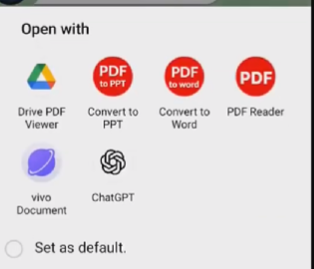  Open with  PDF to PPT  PDF to word  PDF  Drive PDF Viewer  Convert to PPT  Convert to Word  PDF Reader  vivo Document  ChatGPT  Set as default.    Neet Leaked Qus…  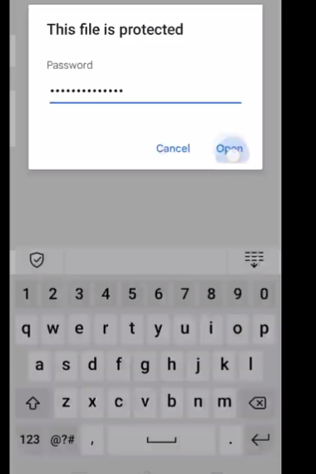  This file is protected  Password  Cancel  Open  1  2  3  4  5  6  7  8  9  0  Q w e r t y u i o p a s d f g h j k l z x c v b n m  123 @  ?#  -  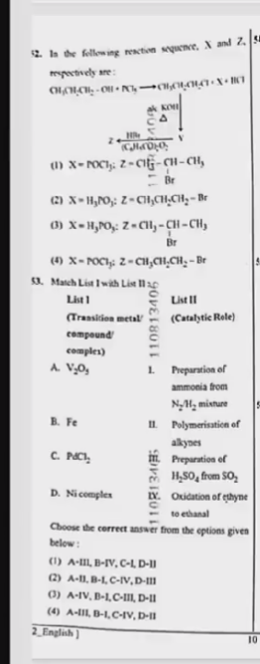  12. In the following reaction sequence, X and Z, respectively are:  5  CH.CH2CH2-OH….  CH3CH2CH2C+X+....  KOH  2 H…  C…H2CO2O2  V  (1) X-POCI: Z-C1-CH-CH,  Br  (2) XH,PO: Z-CH₂CH₂CH₂-Br  (3) X-HPO: Z=CH-CH-CH  Br  (4) X-POCI: Z-CH₂CH₂CH₂-Br  53. Match List I with List ||  List 1 (Transition metal/compound/complex)  Ila 110813406  List II  (Catalytic Role)  A. V2O..  1.  Preparation of ammonia from N₂H₂ mixture  B. Fe  C. PdCl2  II. Polymerisation of alkynes  Preparation of H250, from SO₂  Oxidation of ethyne to ethanal  D. Ni complex  SE 41108134 M  Choose the correct answer from the options given below:  (1) A-III, B-IV, C-L D-II  (2) A-II, B-1, C-IV, D-III  (3) A-IV, B-L,C-III, D-II  (4) A-III, B-L,C-IV, D-II  2_English)  10  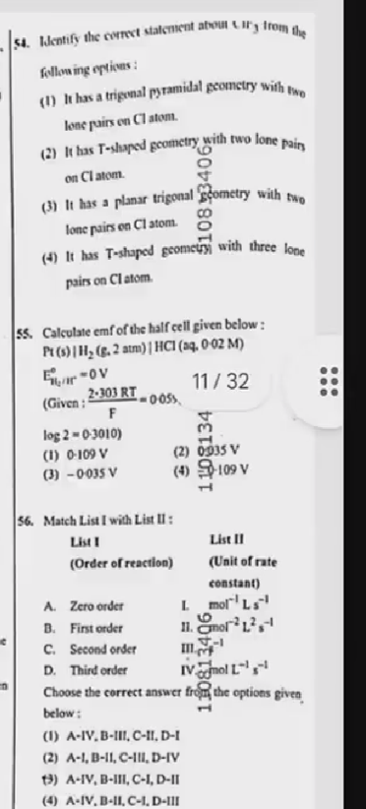  54. Identify the correct statement about….. from the following options:  (1) It has a trigonal pyramidal geometry with two lone pairs on Cl atom.  (2) It has T-shaped geometry with two lone pairs on Cl atom.  108..3406  (3) It has a planar trigonal geometry with two lone pairs on Cl atom.  (4) It has T-shaped geometry with three lone pairs on Cl atom.  55. Calculate emf of the half cell given below: Pt(s) | H₂ (g. 2 atm) | HCl (aq, 0-02 M) EOV (Given: 2-303 RT F -0.05%  10  11/32  log 2-0-3010)  (1) 0-109 V  (2) 0935 V  (3)-0-035 V  (4)109 V  56. Match List I with List II:  List I (Order of reaction)  List II (Unit of rate constant)  A. Zero order  | Mol-1 L5 -1  B. First order  6  || mol-2L2s-1  C. Second order  ||| …-1  110813406  c  n  D. Third order  IV.mol L-1s-1  Choose the correct answer from the options given below:  (1) A-IV, B-III, C-II, D-I  (2) A-1, B-II, C-III, D-IV  (3) A-IV, B-III, C-I, D-II  (4) A-IV, B-II, C-1, D-III  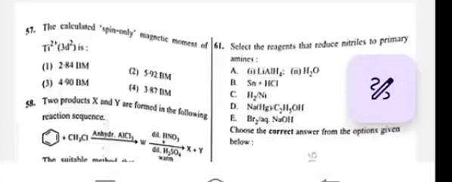  57. The calculated spin-only magnetic moment of Ti2(3d2) is:  (1) 2-84 IM  (2) 592 BM  (3) 4-90 BM  (4) 3-87 BM  58. Two products X and Y are formed in the following reaction sequence.  CH3CI Anhydr. AICI2, 6.HNO3,... H2S04warm  X+Y  The suitable method a...  61. Select the reagents that reduce nitriles to primary amines:  A. (i)LiAH2 (H₂O)  B. Sn+HCI  C. H2Ni  D. Na(Hg)C2H3OH  E. Br2.aq. NaOH  Choose the correct answer from the options given below:  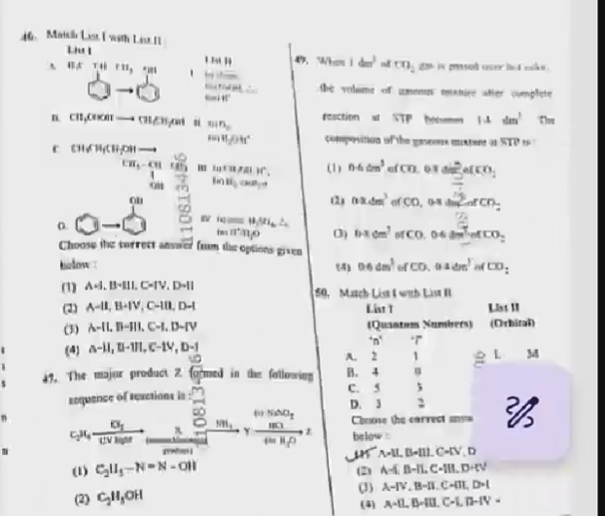  46. Match List I with List II  List I  List II  …….  ……  ……  A….  B CH2C….  C CH.CH2CH2OH  …….  D OH  1108134..6  1  Choose the correct answer from the options given below  (1) A-I, B-III,C-IV, D-II  (2) A-II, B-IV, C-III, D-I  (3) A-II,B-III, C-I.D-IV  (4) A-II, B-III, C-1V, D-I  6  47. The major product Z Formed in the following sequence of reactions in  C2H…….  NH3Y  NaNo2  HCL Z  …..H2O  110813..61  (1) C2H5-N-N-OH  (2) C2H3OH  49. When I …..of CH2….. the volume of ….complete reaction of….  composition of the g…. on STP is-  (1)06 dm2 of CO… CO2  (2) …..of CO .03 ..OF CO2  (3).... dm.. of CD, 0.6dm ..of CO 2  (4) 0.6 dm.. of CO….  50. Match List I with List In  List I  Quantum Numbers)  ‘n’ ‘i’  List II (Orhiral)  A.2  1  B. 4  ..  C. 5  3  - 34  D. 3  2  Choose the correct answer …. below  1 A-II,B-III,C-IV,D…  (2) A-I, B-II,C-III,D-IV  (3) A-IV.B-II-,C-III, D-I  (4) A-II,B-III,C-I,D-IV-  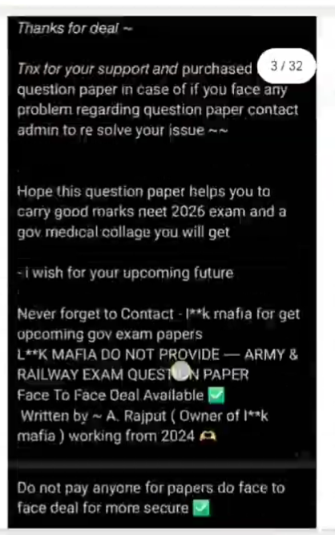  Thanks for deal -  3/32  Tnx for your support and purchased question paper in case of if you face any problem regarding question paper contact admin to re solve your issue~~  Hope this question paper helps you to carry good marks neet 2026 exam and a gov medical collage you will get  - i wish for your upcoming future  Never forget to Contact - I**k mafia for get upcoming gov exam papers  L**K MAFIA DO NOT PROVIDE - ARMY & RAILWAY EXAM QUESTION PAPER  Face To Face Deal Available  Written by A. Rajput (Owner of I**k mafia) working from 2024  Do not pay anyone for papers do face to face deal for more secure  1/32  2/32  3/32  4/32  5/32  6/32  7/32  8/32  9/32  10/32  11/32  12/32  13/32  14/32  15/32  16/32  17/32  18/32  19/32  20/32  21/32  22/32  23/32  24/32  25/32  26/32  27/32  28/32  29/32  30/32  31/32  32/32  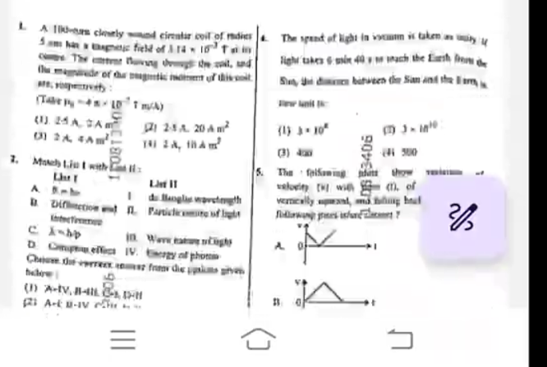  1.A -as closely wound cirr… coil of …. 5m Has netic field of …14- 10-3…. The magnetic of the ….the magnitude of the  ………  (101/A)  (1)25A 2A m2  (3)2 A A m2  101813..01  (2) 2A 20Am2  (4)2A,....m2  25. 20 m²  2. Match List I with List II  List I  A……..  List II  I ………….  B. D…..  II. Part…… of …  C. …..  III.Wave …..  D. Comp… effect  IV. Energy of phot…  Choose the correct… from …….below  …..06  (1) A-IV, B-III,C-I,D-II  (2) A-I,B-IV,C......  4. The spend of light in vacuum is taken as…. light takes 640i search the Earth …..between the San and the Earth …..  (1) 3-10Z  (3)4..  (2) 3-......  (4)500  5. The following that thow of …..vertically….  A0  v  I  B  v  o  I  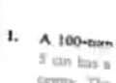  - A 100 - …..  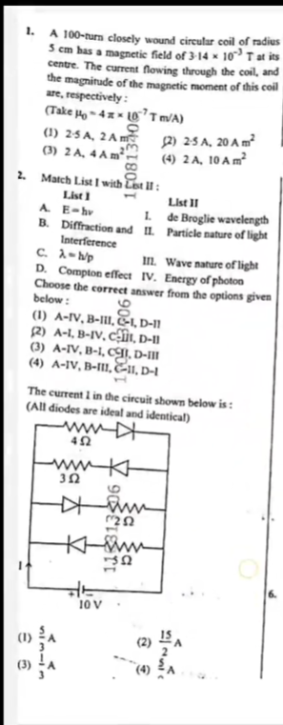  1. A 100-turn closely wound circular coil of radius 5 cm has a magnetic field of 3-14 x 10 T at its centre. The current flowing through the coil, and the magnitude of the magnetic moment of this coil are, respectively:  (Take Ho-4..x10-7Tm/A)  11..0813406  (1) 2-5A, 2A m  (2) 2-5 A, 20 A m²  (3) 2A, 4 Am  (4) 2A, 10 A m²  2. Match List I with List II:  List 1  1  List II  A. E-hv  1. de Broglie wavelength  B. Diffraction and Interference  II. Particle nature of light  C. Ah/p  III. Wave nature of light  D. Compton effect  IV. Energy of photon  Choose the correct answer from the options given below:  …..06  (1) A-IV, B-III, C-1, D-11  (2) A-1, B-IV, CUI, D-11  (3) A–IV, B–1, CI, D–III  (4) A-IV, B-III, 11, D-1  The current I in the circuit shown below is:  1  (All diodes are ideal and identical)  ww  4 Ω  3Ω  1J..313..06  10 V  (1)5/3A  (3)1/3 A  (2)15/2A  (4) 5.. A  6.  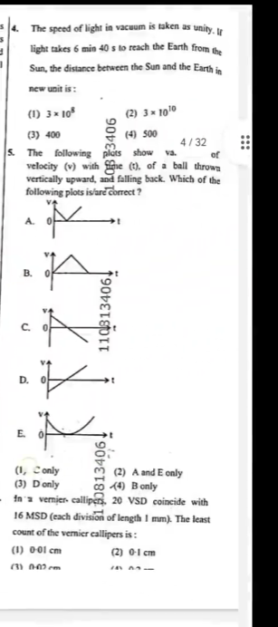  4. The speed of light in vacuum is taken as unity. If light takes 6 min 40 s to reach the Earth from the Sun, the distance between the Sun and the Earth in new unit is:  (1) 3×108  (2) 3x1010  (3) 400  3406  (4) 500  4/32  5.  1.03.3406  The following plots show va. of velocity (v) with me (t), of a ball thrown vertically upward, and falling back. Which of the following plots is/are correct?  - vO  t  B.v 0  t  C.v 0  t  D. v 0 t  E.v0 t  110313406  (1, C only  (3) D only  100813406  (2) A and E only  (4) B only  In a vernier callipers, 20 VSD coincide with 16 MSD (each division of length 1 mm). The least count of the vernier callipers is:  (1) 0-01 cm  (2) 0-1 cm  (3) 002cm  ……..  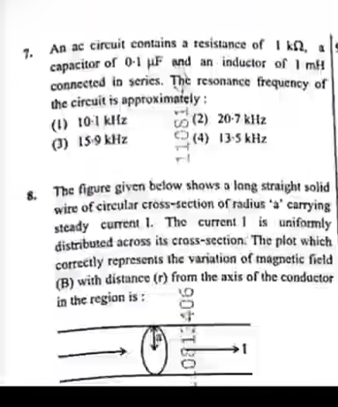  7. An ac circuit contains a resistance of | ΚΩ, α capacitor of 0-1 µF and an inductor of 1 mH connected in series. The resonance frequency of the circuit is approximately:  (1) 10-1 kHz  (2) 20-7 kHz  (3) 15-9 kHz  11081….  (4) 13-5 kHz  8. The figure given below shows a long straight solid wire of circular cross-section of radius 'a' carrying steady current 1. The current 1 is uniformly distributed across its cross-section. The plot which correctly represents the variation of magnetic field (B) with distance (r) from the axis of the conductor in the region is:  10813406  1  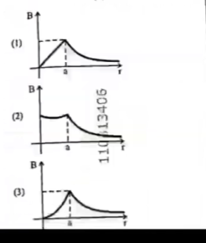  (1)  B  r  (2)  B  a  r  (3)  B  a  r  11013406  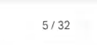  5/32  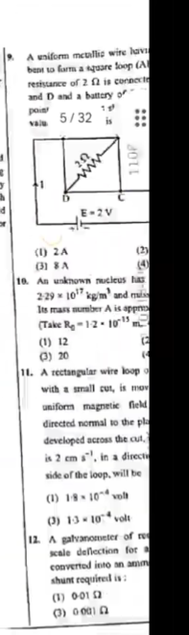  9  A uniform metallic wire hav…. best to farm a square loop (Al… resistance of 2 is connecto….. and D and a battery of… 1 point… valu…. 5/32 is….  1  C  D  2  E-2V  110P  (1) 2A  (2)....  (3) 8A  (4)....  10. An unknown nucleus has…. 2-29 107 kg/m³ and miss….. Its mass number A is appro….. (Take R-12-10-15m…  (1) 12  (2)  (3) 20  11. A rectangular wire ….. o with a small cut, is mov …uniform magnetic field …directed normal to the pla…. developed across the cut….., is 2 cm s", in a directi…. side of the loop, will be  (1) 18 10-4 volt  (3) 1310-4 volt  12. A galvanometer of re… scale deflection for a… converted into an amm…. shunt required is:  (1) 001  (3)0001  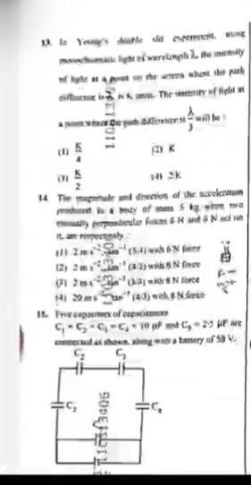  13. In Yeny's suble …….slit…..light of wa……They of light……  19011  Y  (1)K/4  (2) K  (3)K/2  (4)2K  14 The magnitude and direction of the……… 5kg ………  ……  (1) 2 ms,,,,  ….  with 8 N force  (2) 2m-2……  (3) 2m-2 …. N force  (4) 20 m ….. N force  12. Five sepanex of exp…  C1 - c2 - c3 - c4 - 10 .. and c..-.....  …………..50 V  C2  C3  C2  C4  ….  …113406  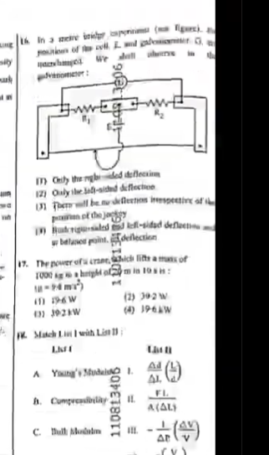  …  16. In ………..  ……  i………..  R1  R2  3806  (1) Only the ri….. deflection  (2) Only the left-sided deflection  (3) There will be no deflection irrespective of the….. of the jockey  (4) ………. send left-sided deflection….. belaser point… deflection  17. The power of crane, which lifts a mass of 1000 kg height of m in 1o…: 24m²)  …  (1) 196W  (2) 30-2 W  (3) 392kW  (4) 19-64W  Match List(I) with List (II)  A Young's Mudais  1.  Ad DI  A. Comp……  110813400  II.  FL  A(AL)  C. Bull Modalm  III.  I V  V  V  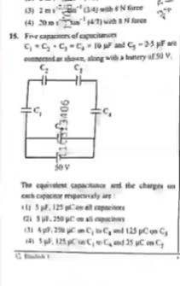  (3) 2m (3/4) with & N force (3) 2m  (4) 30m4/7) with & Ni foren  15. Five cap….. of capacitance  ……………..  C2  C3  C1  C4  50V  13406  The equivalent capacitance and the charges on each c…… respectively are:  (1)15.125 Con all capacitors  (2) 5…215 m. ……  (3) 4…..250C….  (4) 5 …. 125…..25…C  ……  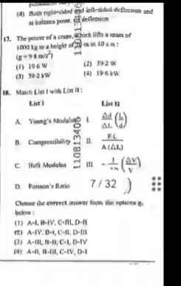  …..  (4) Both right-sided and left-ssed defincan und at balanes…….  17. The power of a crane. Which lifts a pass of 1000 kg te z height of 20 10…  …  (1) 196W  (2) 392W  (3) 39-21W  (4) 196kW  18. Ma…. List I…..  List I  List II  A. Young's Modal  B. Compressibility  110813405  11.  FL  A (AL)  C. Hut Modulus  -()  V  D. Poisson's Ratio  7/32)  Choose the correct answer from the options  below:  (1) A-1, B-IV, C-III, D-II  (2) A–IV. D-I, C-II, D-III  (3) A-III, B-II, C-1, D-IV  (4) A-II, I-III, C-IV, D-1  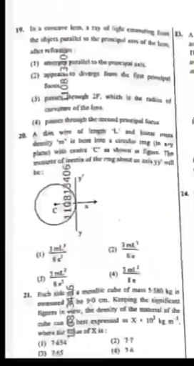  19. In a concave kem, a ray of light………..  …..  (1)............axis.  (2) …….divergs from the first primate force  (3) …….2F, which is the radius of curvature of the …  (4) passes through the ……focus  28. A din wire of……  ……'m' is bom plane) Config.The manent of inestix of the ring shat un axis yy be:  110818406  24.  - 3ml..  (2) 3ml/…  (3) 3ml2…  (4) 3ml 2…  21. Each side meallic….. cube of mass 5.580 kg is ……90 cm. Keeping the significant figures in view, the density of the material of the bean best expressed X10 kg m where of X is:  (1) 7654  (2) 7:7  (3) 7:45  (4) 7:4  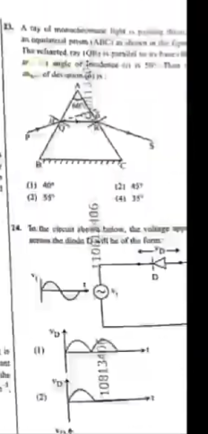  23. ……….  …..  (1) 40  121 457  (3) 55  (2) 45  (4) 35  110406  14. In the circuit…….., the voltage apply…..  D  D  - D v  (2)  D  108134)  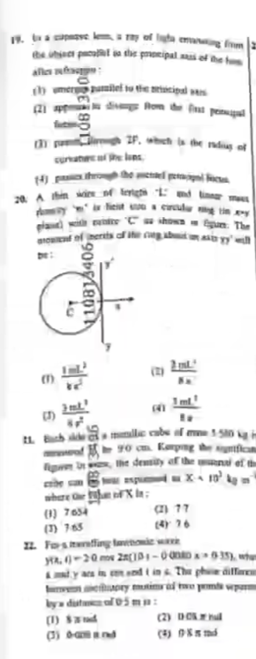  19. …………of the  (1) ……to the …..sars….  (2) app Rom the first penugal  ZP. which is the radius of curates of the……,  (4) ….the ….perin facts  20. A then …….  110814406  2 mL (2)  1 ml  11. ……..  (1) 7654  (2) 77  (3) 765  (4)76  22. ……05mm:  (1)$  (2) 0-0  (3)  (4) m  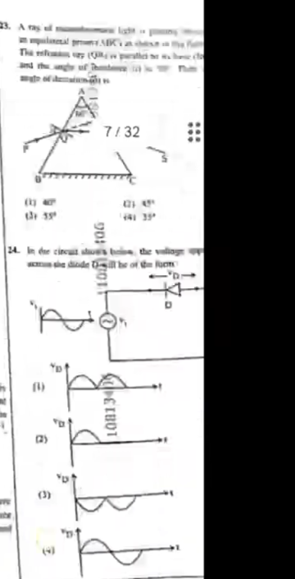  3. A ray ……  - 40…  (2)...  (3)..5.  (4)...  10813…26  D D  7/32  24. ………  100  (1).....  (2)....  (3)....  (4).....  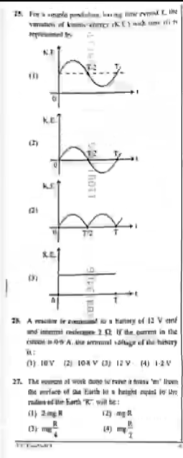  …….  120…..6  ..10 v  ….10 …..v  ..1.2 V  (4)1.2 V  27….  …..  …..  R..  …  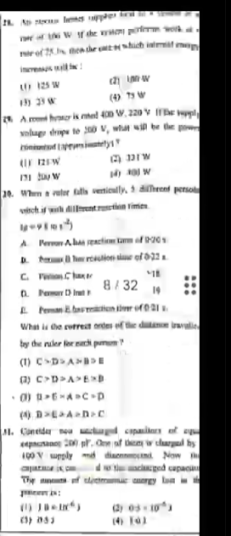  ……. … . …  …..125 W  (3) 23 W  (4) 75W  …… …..  …..125 W  A ….A….  B …. B…  C ….C….  D ….D…  8/32  20. …..  …..  (1) CDABE  (2)CDAEB  (3) CDAEXB  (4) DEADC  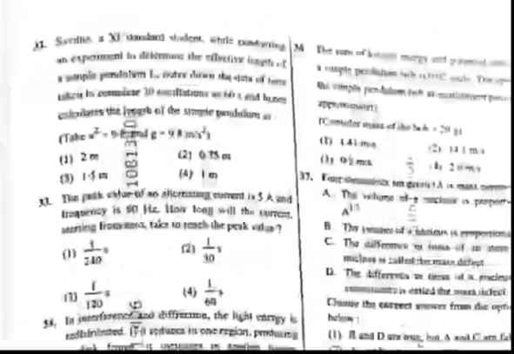  …….W….  (1) 2m  …W  ….  (4)...  31. …….  (0)  2410  1 10  120  …….. . .. .  (1) 441 me  (2) 075 si  A…..  …..  C. ……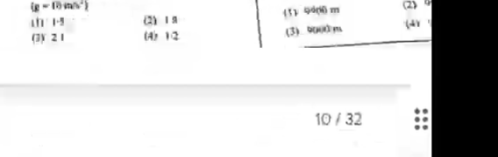  - 1-...  (2)1…  (3)2…  (4)1.2  … . .. . ..  (2)....  (3)....  (4).....  10/32  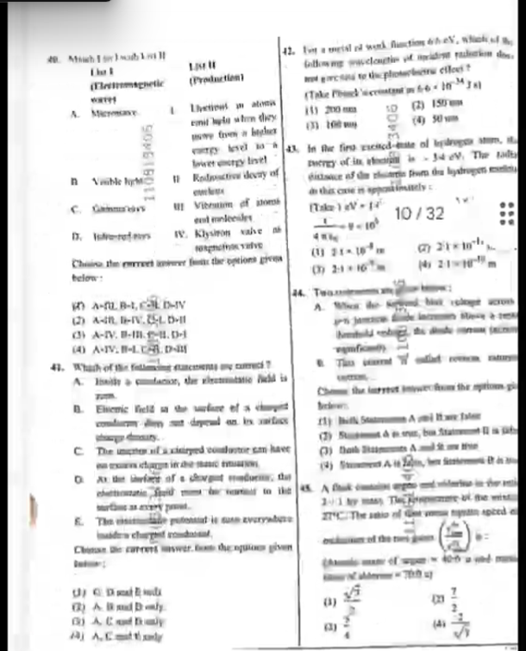  40. .. … ..  LIST I LIST II  A . …  B …  C .. .  D …  I . ..  II …  III …  IV …  … ……..  41. Wh…….  A. ……  B. ……  C. The ……  D. ……  ……. .. . . .. .  1 C D AND …  2 A B AND….  3 A C AND ….  4 AC AND …..  42. ………  (Take …….  [1]200…..  (3)100….  (2) 150…..  (4)50…….  43. In ……..  10/32  …  (1)21X10  ….  ..  10/32  ……  …………  (1) ….  (2)7/2  (3)2../4  (4).../..7  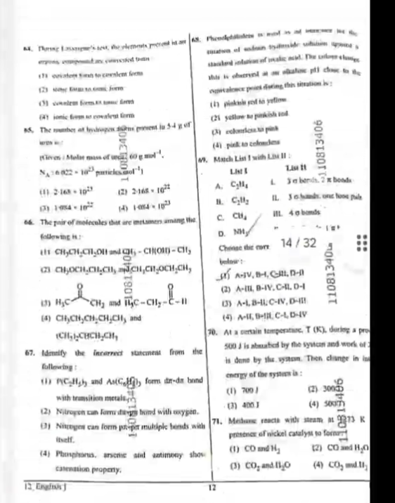  64. ……….  1…..  2….  3…..  4……  65. The number ……  (1)2….10..2  (2) 2….10..22  (3)...4..10….  (4).....10…  66. The pair of …….. following ….  [1]CH.. …CH… CH… CH….CH  [2] CH.. …CH… CH… CH….CH …CH.. …CH… CH… CH….CH  3) H..C ….CH₂ and 14C-..CH-C-.....  (4) CH.. …CH… CH… CH….CH and CH.. …CH… CH… CH….CH  67. Identify the incorrect statement from the following:  (1)P..C..H…. and A…C…, form …..with transition metals  (2) Nitrogen can ….. bond with…….  [3] Nitrogen can form ……multiple bonds with itself.  (4) Phosp……. C…… property.  6. …….  (1) …….yellow  (21 yellow to …..  (3)......  (4) pick to ……  49. Match List I with List II:  List I  Liss II  A . C2H4  B. C2H2  C. CH4  D. ..H  I ….  II ….  III….  IV…..  Choose the corr….. below:  14 / 32  (2) A-III, B-IV, C-II, D-I  (3) A-I , B-II , C-IV, D-III  (4) A-II B-III , C-I , D-IV  11081340  70. At a certain temperature, T (K), during a pro 500 J is …….the system. Then change in in energy of the system is:  (1) 700/  (2) 300  (3) 400…  (4) 507..  110813406  11081340…  11081..4…6  71. Ma…..  (1) CD and H  (2) CO and H₂O  (3) CO, and 10  (4) CO, md.  12. English  12  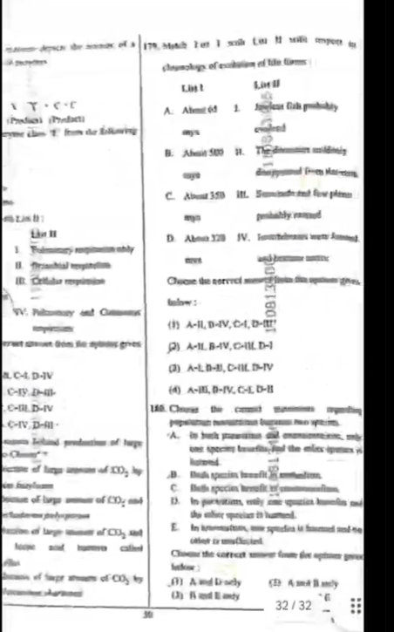  LIST II  I …  II …  III …  IV ….and …..  …c4 d iv  C iv d iii  Ciii div  Civ dii  …..CO2  …. Co2  …..  179. M……  LIST I LIST II  A B C D  I II III IV  65  500  350  Choose …..  A A 1  B. Ah 500  ….  …  (1)A-ILD-IV,C,  A-ILB-AV, CHILD-1  (3) ALD-B, C-ILD-TV  (4) A-, B-IV,C-LD-H  146. Choose the ….  ….  A …  B ….  C …  D …  (1).....  (2) ,....  (3) ….  (4) ….  …01  1..0813….  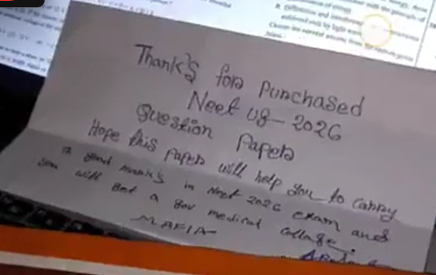  Thank's for Purchased  Neet …8-2026  Question Paper  Hope this papers will help you to carry  Th god manic's in Nest 2026 exam and  with Bat a gov medical collage  MAFIA  AR….  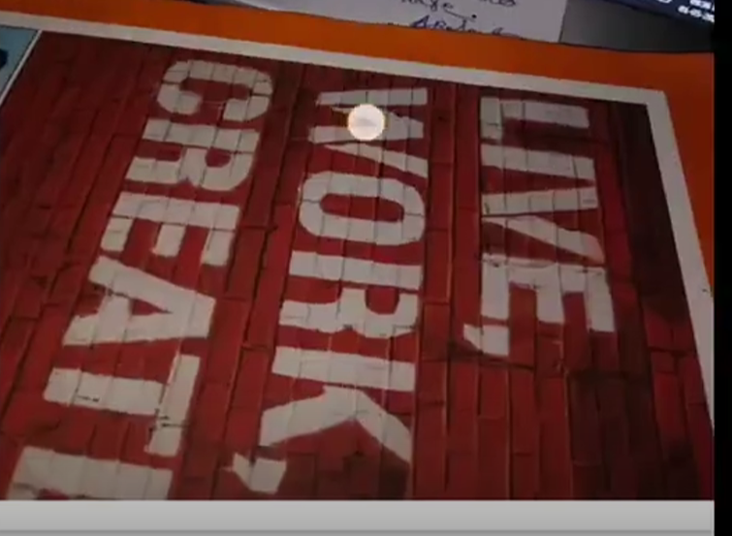  LIVE, WORK, CREATE…  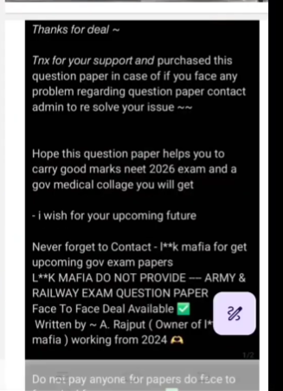  Thanks for deal ~  Tnx for your support and purchased this question paper in case of if you face any problem regarding question paper contact admin to re solve your issue ~~  Hope this question paper helps you to carry good marks neet 2026 exam and a gov medical collage you will get  - i wish for your upcoming future  Never forget to Contact - I**k mafia for get upcoming gov exam papers  L**K MAFIA DO NOT PROVIDE -- ARMY & RAILWAY EXAM QUESTION PAPER Face To Face Deal Available Written by A. Rajput (Owner of I* mafia) working from 2024  1/2  Do not pay anyone for papers do face to  Connecting……  165 09.22  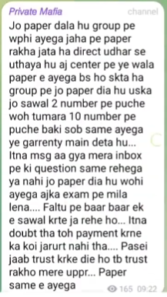  The paper I have added in the group, the same would come. I have picked it from where the papers are kept. Today this paper would come in the center but it’s possible the question number 2 in the paper added in the group may be asked in question number 10, the rest all will come the same, I give this guarantee. I have received so many messages in my inbox whether the question will remain the same or not, compare it with the exam today… You’re illogically asking the same question again and again. If you had so much doubt then there was no need to send payment. If you have given money based on trust then trust me, the same paper would come.  165 09:22  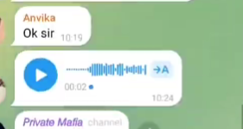  Anvika  Ok sir  10:19  00:02.  10:24  Private Mafia channel  166 10.24  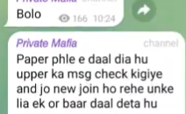  Speak  166 10:24  Private Mafia:  I have already added the paper, check the top message and I will add again for those who have newly joined.  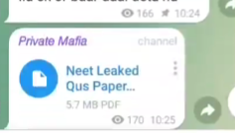  166  10:24  Private Mafia  channel  Neet Leaked Qus Paper...  5.7 MB PDF  170 10:25  The paper is already added, check the top message  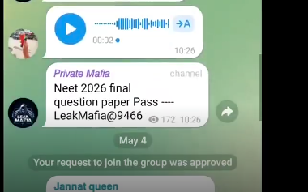  A  00:02.  10:26  Private Mafia  channel  Neet 2026 final question paper Pass ----LeakMafia@9466  172  10:26  MAFIA  May 4  Your request to join the group was approved  Jannat queen  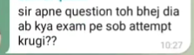  Sir you have sent the question, now would I attempt all in the exam?  10:27  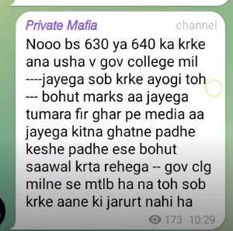  173 10:29  No, only come by doing 630 or 640, it will be available in gov college. If you will do all then a lot of marks would come and then media will come at your home, how much hours you study, how did you study, all these kind of questions will be asked. The intention is to get gov college, there is no need to do all.  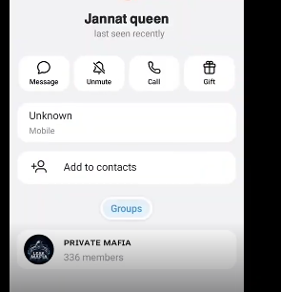  Jannat queen  last seen recently  Message  Unmute  Call  Gift  Unknown  Mobile  Add to contacts  Groups  PRIVATE MAFIA  336 members  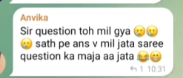  Anvika  Sir, the question is provided but it would have been fun if answers were also provided.  1 10:31  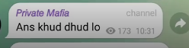  Find the answer yourself.  173 10:31  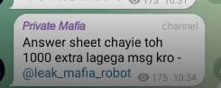  If you want the answer sheet then it would cost an extra 1000, send a message.  @leak_mafia_robot  175 10:34  Mr sharma  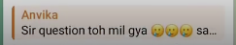  Sir, the question is found… Sa    Hey anvika where you are from which state  10:35  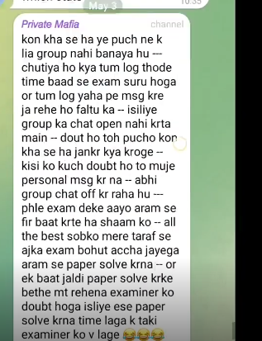  I have not made the group to ask who is from where. Are you people idiots, exam is after some time and you people are sending nonsense messages here, that is why I don’t open group chat here. If you have doubt, then ask. What would you do by asking who is from where? If someone has any doubt, they should message me personally. Now I’m turning off the group message. First check the exam comfortably then we will talk in the evening. All the best to all from my side, today’s exam will go well, solve the paper comfortably. And one more thing, don’t sit by solving the paper quickly, the examiner will get in doubt that is why solve paper in such a manner where the examiner feels you don’t know anything but you already received the paper before the exam and you already solved it.  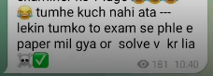  You don’t know anything but you received the paper before the exams and you solved it too.  181 10:40  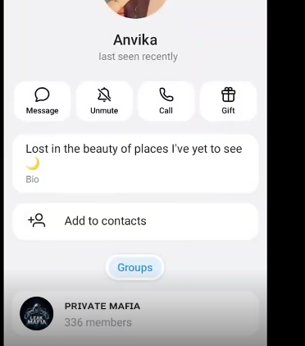  Anvika  last seen recently  Message  Unmute  Call  Gift  Lost in the beauty of places I've yet to see  Bio  +  Add to contacts  Groups  LEAK MAFIA  PRIVATE MAFIA  336 members  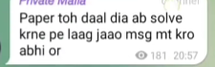  I have added the paper now start solving it, don’t send any more message.  181 20:57    How did the exam go?  1 182 09:36  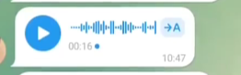  00:16.  State→A  10:47  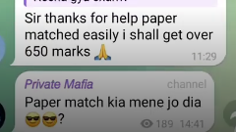  Did the paper match which I provided?  11:29  189 14:41  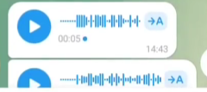  00:05  14:43  →A  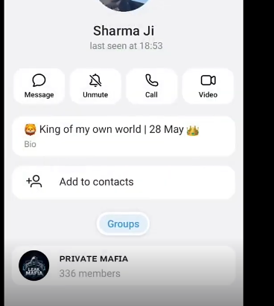  Mr Sharma  last seen at 18:53  Message  Unmute  Call  Video  King of my own world |  28 May  Bio  Add to contacts  Groups  LEAK MAFIA  PRIVATE MAFIA  336 members  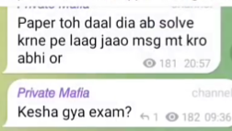  I have added the paper now start solving it, don’t send any more message.  181 20:57  Private Mafia:  channel  How did the exam go?  1 182 09:36  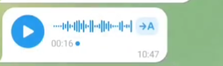  00:16.  A  10:47  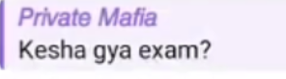  How did the exam go?  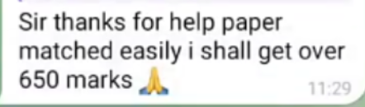  Sir thanks for help paper matched easily i shall get over 650 marks  11:29  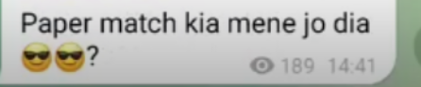  Did the paper match which I provided?  189 14:41  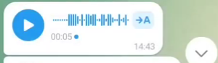  00:05.  →A  14:43  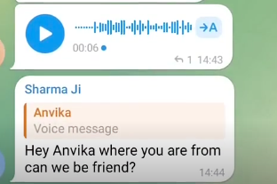  →A  00:06  1 14:43  Mr Sharma  Anvika  Voice message  Hey Anvika where you are from can we be friend?  14:44  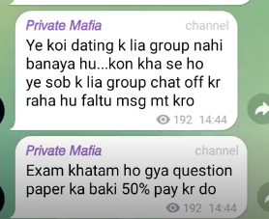  I have not made this group for dating… Who is from where, for this I’m turning off, don’t send nonsense messages.  192 14:44  Exam has finished, pay the remaining 50% of the question paper.    00:04.  A  14:45    WHAT ABOUT THE STUDENTS WHO REALLY STUDIED?  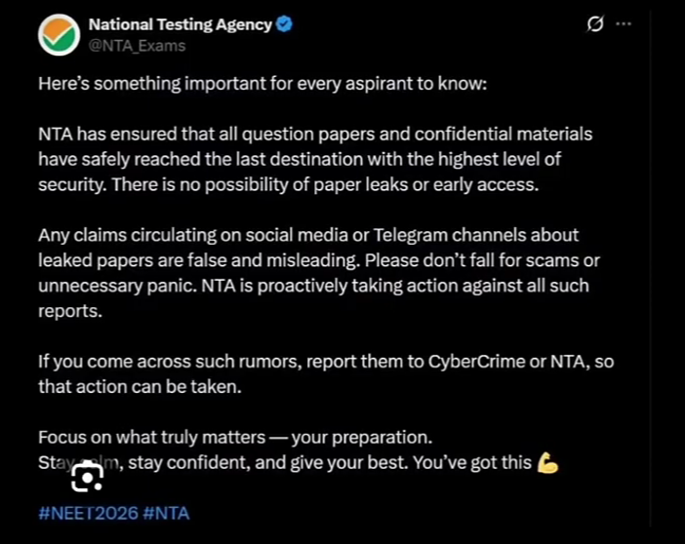  National Testing Agency  @NTA_Exams  Here's something important for every aspirant to know:  NTA has ensured that all question papers and confidential materials have safely reached the last destination with the highest level of security. There is no possibility of paper leaks or early access.  Any claims circulating on social media or Telegram channels about leaked papers are false and misleading. Please don't fall for scams or unnecessary panic. NTA is proactively taking action against all such reports.  If you come across such rumors, report them to CyberCrime or NTA, so that action can be taken.  Focus on what truly matters - your preparation.  Stay……m, stay confident, and give your best. You've got this  #NEET2026 #NTA  ...    ENSURED AT WHAT COST? | Note - There is very fast moving question paper ost in timestamps [00:00:19-00:00:29]  Insane, Insane:  Implying that the lover was so devoted in love and his passion was so deep and unconventional that people who couldn't feel it mistook the lover’s devotion for madness.  Prostration:  https://en.wikipedia.org/wiki/Prostration  Telegram:  https://en.wikipedia.org/wiki/Telegram_(software)  NEET-UG:  https://en.wikipedia.org/wiki/National_Eligibility_cum_Entrance_Test_(Undergraduate)  Started staying in prostration of my beloved so much:  This line implies a state of total surrender and spiritual devotion, where the lover has abandoned their ego to find complete peace in worshipping their beloved.  Catering to my every colorful need:  The “Urdu” word used in the line holds different meanings like “need, care, love”. The singer is implying that the lover was pampering their lover a lot and was indulging in the every need and care of her beloved.  sitting memories down beside me:  Literal translation of the line and implying that the lover kept the memories of their beloved close by their side.
00.01.00 - 00.02.00 | Music + non-lexical sound [00:01:00 - 00:01:07] |   National Testing Agency  @NTA_Exams  Here's something important for every aspirant to know:  NTA has ensured that all question papers and confidential materials have safely reached the last destination with the highest level of security. There is no possibility of paper leaks or early access.  Any claims circulating on social media or Telegram channels about leaked papers are false and misleading. Please don't fall for scams or unnecessary panic. NTA is proactively taking action against all such reports.  If you come across such rumors, report them to CyberCrime or NTA, so that action can be taken.  Focus on what truly matters - your preparation.  Stay……m, stay confident, and give your best. You've got this  #NEET2026 #NTA  ...    ENSURED AT WHAT COST?    "WHAT IS THE COST OF THE LIVES OF STUDENTS WHO DIE BY SUICIDE EACH YEAR DUE TO NOT GETTING A SEAT?"    50-60K ???  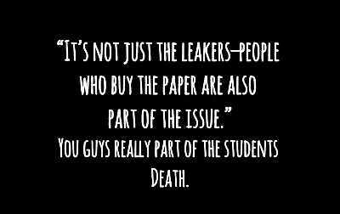  "IT'S NOT JUST THE LEAKERS-PEOPLE WHO BUY THE PAPER ARE ALSO PART OF THE ISSUE."  YOU GUYS REALLY PART OF THE STUDENTS DEATH.
00.02.00- 00.03.00
00.03.00- 00.04.00
00.04.00- 00.05.00
00.05.00-00.06.00
00.06.00-00.07.00
00.07.00-00.08.00
00.08.00-00.09.00
00.09.00-00.10.00
00.10.00-00.11.00
00.11.00-00.12.00
00.12.00-00.13.00
00.13.00-00.14.00
00.14.00-00.15.00
00.15.00-00.16.00
00.16.00- 00.17.00
00.17.00- 00.18.00
00.18.00- 00.19.00
00.19.00- 00.20.00
00.20.00-00.21.00
00.21.00-00.22.00
00.22.00-00.23.00
00.23.00- 00.24.00
00. 24.00- 00.25.00
00.25.00-.00.26.00
00.26.00-00.27.00
00.27.00-00.28.00
00.28.00-00.29.00
00.29.00-00.30.00
00.30.00-00.31.00
00.31.00-00.32.00
00.32.00-00.33.00
00.33.00-00.34.00
00.34.00-00.35.00
00.35.00-00.36.00
00.36.00-00.37.00
00.37.00-00.38.00
00.38.00-00.39.00
00.39.00-00.40.00
00.40.00-00.41.00
00.41.00-00.42.00
00.42.00-00.43.00
00.43.00-00.44.00
00.44.00-00.45.00
00.45.00-00.46.00
00.46.00-00.47.00
00.47.00-00.48.00
00.48.00-00.49.00
00.49.00-.00.50.00
00.50.00-00.51.00
00.51.00-00.52.00
00.52.00-00.53.00
00.53.00-00.54.00
00.54.00-00.55.00
00.55.00-00.56.00
00.56.00-00.57.00
00.57.00-00.58.00
00.58.00-00.59.00
00.59.00-01.00.00
01.00.00-01.01.00
01.01.00-01.02.00
01.02.00-01.03.00
01.03.00-01.04.00
01.04.00-01.05.00
01.05.00-01.06.00
01.06.00-01.07.00
01.07.00-01.08.00
01.08.00-01.09.00
01.09.00-01.10.00
01.10.00-01.11.00
01.11.00-01.12.00
01.12.00-01.13.00
01.13.00-01.14.00
01.14.00-01.15.00
01.15.00-01.16.00
01.16.00-01.17.00
01.17.00-01.18.00
01.18.00-01.19.00
01.19.00-01.20.00
01.20.00-01.21.00
01.21.00-01.22.00
01.22.00-01.23.00
01.23.00-01.24.00
01.24.00-01.25.00
01.25.00-01.26.00
01.26.00-01.27.00
01.27.00-01.28.00
01.28.00-01.29.00
01.29.00-01.30.00
01.30.00-01.31.00
01.31.00-01.32.00
01.32.00-01.33.00
01.33.00-01.34.00
01.34.00-01.35.00
01.35.00-01.36.00
01.36.00-01.37.00
01.37.00-01.38.00
01.38.00-01.39.00
01.39.00-01.40.00
01.40.00-01.41.00
01.41.00-01.42.00
01.42.00-01.43.00
01.43.00-01.44.00
01.44.00-01.45.00
01.45.00-01.46.00
01.46.00-01.47.00
01.47.00-01.48.00
01.48.00-01.49.00
01.49.00-01.50.00
01.50.00-01.51.00
01.51.00-01.52.00
01.52.00-01.53.00
01.53.00-01.54.00
01.54.00-01.55.00
01.55.00-01.56.00
01.56.00-01.57.00
01.57.00-01.58.00
01.58.00-01.59.00
01.59.00-02.00.00
02.00.00-02.01.00
02.01.00-02.02.00
02.02.00-02.03.00
02.03.00-02.04.00
02.04.00-02.05.00
02.05.00-02.06.00
02.06.00-02.07.00
02.07.00-02.08.00
02.08.00-02.09.00
02.09.00-02.10.00
02.10.00-02.11.00
02.11.00-02.12.00
02.12.00-02.13.00
02.13.00-02.14.00
02.14.00-02.15.00
02.15.00-02.16.00
02.16.00-02.17.00
02.17.00-02.18.00
02.18.00-02.19.00
02.19.00-02.20.00
02.20.00-02.21.00
02.21.00-02.22.00
02.22.00-02.23.00
02.23.00-02.24.00
02.24.00-02.25.00
02.25.00-02.26.00
02.26.00-02.27.00
02.27.00-02.28.00
02.28.00-02.29.00
02.29.00-02.30.00
02.30.00-02.31.00
02.31.00-02.32.00
02.32.00-02.33.00
02.33.00-02.34.00
02.34.00-02.35.00
02.35.00-02.36.00
02.36.00-02.37.00
02.37.00-02.38.00
02.38.00-02.39.00
02.39.00-02.40.00
2.40.00-02.41.00
2.41.00-02.42.00
2.42.00-02.43.00
2.43.00-02.44.00
2.44.00-02.45.00
2.45.00-02.46.00
2.46.00-02.47.00
2.47.00-02.48.00
2.48.00-02.49.00
2.49.00-02.50.00
2.50.00-02.51.00
2.51.00-02.52.00
2.52.00-02.53.00
2.53.00-02.54.00
2.54.00-02.55.00
2.55.00-02.56.00
2.56.00-02.57.00
2.57.00-02.58.00
2.58.00-02.59.00
2.59.00-03.00.00

